Classic Lifts (Scotland) Ltd offers all aspects of lift engineering including maintenance, installation, modernisation, repair, 24 hour emergency call out facility and all other lift related services.
We take pride in our professional, friendly approach and long term commitment and alliance to our customers. We use our experience and expertise in the lift industry to provide our customers with the highest quality service.
To help us achieve these aims we operate an Integrated Management System (IMS) that specifies how we manage Health & Safety, Environmental and Quality (HSEQ) aspects of our operations. Classic Lifts are committed to continuous improvement in all aspects of their operations and will:
Protect the health and safety of employees, contractors, customers and the public by -
- Meeting the requirements of ISO 45001
- Complying with the LEIA (Lift and Escalator Industry Association) Safety Charter that commits us to working in accordance with BS7255 – Safe Working on Lifts
- Ensuring lift installations comply with the Lift Regulations (where applicable)
- Complying with all relevant health and safety legislation
- Providing relevant health and safety information to customers
- Ensuring that the prevention of injury and ill health is off prime importance
- Establishing and maintaining safe systems of work by using the hierarchy of risk control to eliminate hazards and reduce risks wherever practical
- Ensuring all employees understand their responsibility for health and safety
- Consulting with our employees and subcontractors and encouraging participation in our H&S system
Protect and minimise our impact on the environment by -
- Meeting the requirements of ISO 14001
- Complying with all relevant environmental legislation
- Reducing fuel and energy usage
- Preventing pollution.
- Considering the lifecycle of the products we supply
- Minimising and segregating waste
- Involving all employees in this process
Enhance customer satisfaction by -
- Meeting the requirements of ISO 9001 and other applicable requirements
- The effective application of an Integrated Management System.
- Ensuring continuity of supply
- Providing technical support for all our products and services
- Ensuring all employees understand their responsibilities in this area
To ensure continual improvement, we identify specific measurable objectives and set HSEQ targets that are consistent with our overall strategy. We also undertake regular monitoring, internal audits and reviews of the company’s activities, objectives and targets.
All employees understand the importance of operating to this Policy, and are invited to contribute ideas for improvements. The HSEQ Policy is communicated to all our employees and is publicly available on our website.

Signed: | 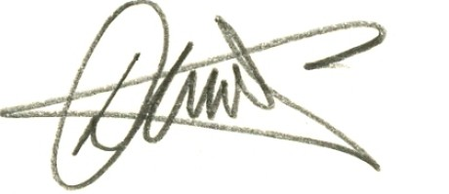 | Date: | 28-07-22
David A McColl
Managing Director

